C9 PREP
  - Vernon Koo Hern Xhen
1. What is the resolution of the ADC?
10-bit resolution (0-1023)
2. How many input channels are available for single ended input, and where can they be found?
There are 8 Multiplexed Single Ended Input Channels. They can be found on Port A on the Il Matto Board.
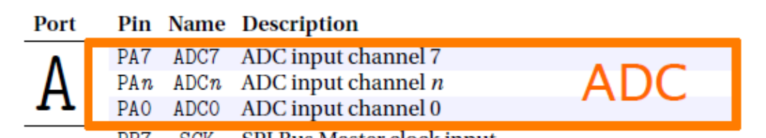
3. How is a channel selected for single ended input?
The analog input channel is selected by writing to the MUX bits in ADMUX.
ADMUX = n;
4. If the ADC is configured for single ended input and returns a result of 0x00FF what is the voltage that was measured?
10-bit resolution implies that there are $2^{10}=1024 steps.$
Therefore, the 0 – 3.3V range is divided into 1024 steps. Thus, a 0V input will give an ADC value of 0, while 3.3V will give an ADC output of 1023.
Using the formula,
$$ADC=V_{in}×\frac{1024}{V_{ref}}$$
$$V_{in}=\frac{ADC×V_{ref}}{1024}$$
As 0x00FF is equivalent to 255 in decimal,
$$V_{in}=\frac{255×3.3}{1024}=0.822V$$

5. What clock pre-scaler settings are supported by the ADC? What is the fastest pre-scaler setting that can be used whilst maintaining full precision?
The clock pre-scalers settings that are supported by the ADC are 2,4,8,16,32,64,128. Since the ADC clock needs to be between 50 kHz & 200 kHz for 10-bit accuracy, we can only use the 64 prescaler and achieve a 187 kHz ADC clock.
6. How many clock cycles are required to capture a measurement on a single ended input?
A normal conversion takes 13 ADC clock cycles. The first conversion after the ADC is switched on (ADEN in ADCSRA is set) takes 25 ADC clock cycles in order to initialize the analog circuitry.

7. Write a C statement to configure the pre-scaler setting calculated above and enable the ADC.
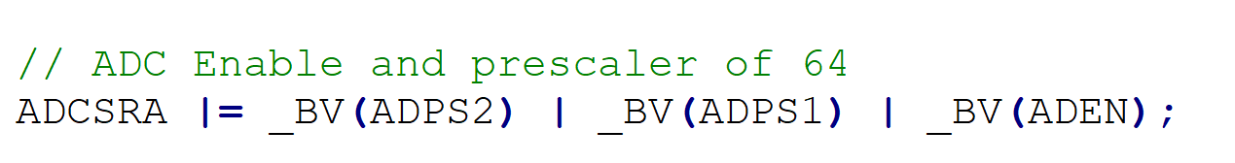

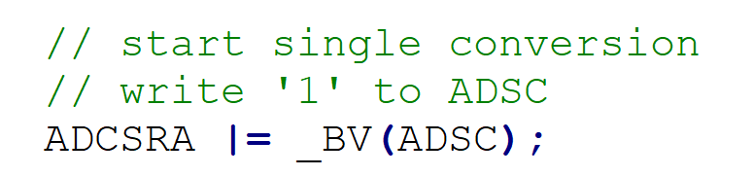
8. Write a C statement that starts a single conversion.

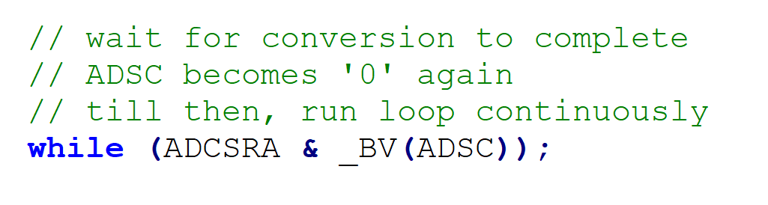
9. Write a C statement that waits until a conversion is complete.

10. What is auto triggering, and what events are supported?
When Auto Triggering is used, the prescaler is reset when the trigger event occurs. This assures a fixed delay from the trigger event to the start of conversion. In this mode, the sample-and-hold takes place 2 ADC clock cycles after the rising edge on the trigger source signal. Three additional CPU clock cycles are used for synchronization logic.
Bit 5 – ADATE: ADC Auto Trigger Enable When this bit is written to one, Auto Triggering of the ADC is enabled. The ADC will start a conversion on a positive edge of the selected trigger signal. The trigger source is selected by setting the ADC Trigger Select bits, ADTS in ADCSRB.
Events supported are as below,
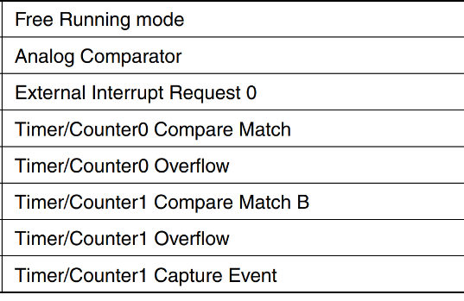

Source: Atmega644p datasheet pg237

11. What is free running mode and how is it enabled?
In Free Running mode, a new conversion will be started immediately after the conversion completes, while ADSC remains high.
It can be enabled by setting the ADATE bit in ADCSRA to 1 and set ADTS2, ADTS1 and ADTS0 bits in ADCSRB to 0.

Source: Atmega644p datasheet pg237

